Setiap toko yang berskala besar pasti memiliki tempat penyimpanan barang yang disebut dengan nama gudang yang terpisah dari toko tempat berjulan apalagi barang-barang tersebut berukuran besar. Dan biasanya barang-barang yang baru dibeli tidak langsung masuk ke dalam toko tetapi ditampung terlebih dahulu di gudang penyimpanan. Baru setelah barang di toko mulai berkurang maka barang dari gudang akan dikeluarkan ke toko. Dan pada aplikasi ini akan mencatat proses keluar masuk barang dari gudang atau dari toko. Di dalam aplikasi ini saya hanya membatasi dua buah gudang penyimpanan barang dan sebuah toko dan jika anda akan menambahkannya silahkan saja.

Yang diperlukan untuk membuat form mutasi barang ini adalah :

|  |  |  |
| --- | --- | --- |
| **Object** | **Properties** | **Setting** |
| **Form** | Name | frmJenisBarang |
|  | BorderStyle | 0-None |
|  | BackColor | &H00FFC0C0& |
|  | StartUpPosition | 2-CenterScreen |
| **Label** | Name | Label1 |
|  | Font | Calibri |
|  | ForeColor | &H8000000D& |
|  | Caption | Form Mutasi Barang |
|  | Name | Label2 |
|  | Font | Calibri |
|  | ForeColor | &H8000000D& |
|  | Caption | Tanggal Mutasi |
|  | Name | Label3 |
|  | Font | Calibri |
|  | ForeColor | &H8000000D& |
|  | Caption | Tempat Asal |
|  | Name | Label4 |
|  | Font | Calibri |
|  | ForeColor | &H8000000D& |
|  | Caption | Tempat Tujuan |
|  | Name | Label5 |
|  | Font | Calibri |
|  | ForeColor | &H8000000D& |
|  | Caption | Keterangan |
|  | Name | Label6 |
|  | Font | Calibri |
|  | ForeColor | &H8000000D& |
|  | Caption | Nama Barang |
|  | Name | Label7 |
|  | Font | Calibri |
|  | ForeColor | &H8000000D& |
|  | Caption | Jumlah |
| **Textbox** | Name | TxtKet |
|  | Appearance | 0-Flat |
|  | Height | 330 |
| **VBButton** | Name | CmdSave |
|  | ButtonType | 4-Mac |
|  | Caption | &Save |
|  | Name | CmdCancel |
|  | ButtonType | 4-Mac |
|  | Caption | &Cancel |
|  | Name | CmdInput |
|  | ButtonType | 4-Mac |
|  | Caption | &Cari |
|  | Name | vbButton1 |
|  | ButtonType | 3-WindowsXP |
|  | Caption | - |
|  | BackColor | &H00FFC0C0& |
|  | Name | vbButton2 |
|  | ButtonType | 3-WindowsXP |
|  | Caption | X |
|  | BackColor | &H00FFC0C0& |
| **SSOleDBCombo** | Name | CmbAsal |
|  | BackColorOdd | &H00FFC0C0& |
|  | DataMode | 2-ssDataModeAddItem |
|  | Isian | Gudang 1 |
|  |  | Gudang 2 |
|  |  | Toko |
|  | Name | CmbTujuan |
|  | BackColorOdd | &H00FFC0C0& |
|  | DataMode | 2-ssDataModeAddItem |
|  | Isian | Gudang 1 |
|  |  | Gudang 2 |
|  |  | Toko |
|  | Name | CmbBarang |
|  | BackColorOdd | &H00FFC0C0& |
|  | DataMode | 2-ssDataModeBound |
| **Adodc** | Name | Adodc1 |
| **TDBGrid** | Name | Grid |
|  | DeadAreaColor | &H00FFC0C0& |
|  | ColumnFooter | False |
|  | MarqueeStyle | 2-HighlightCell |

Tampilan design form mutasi barang :

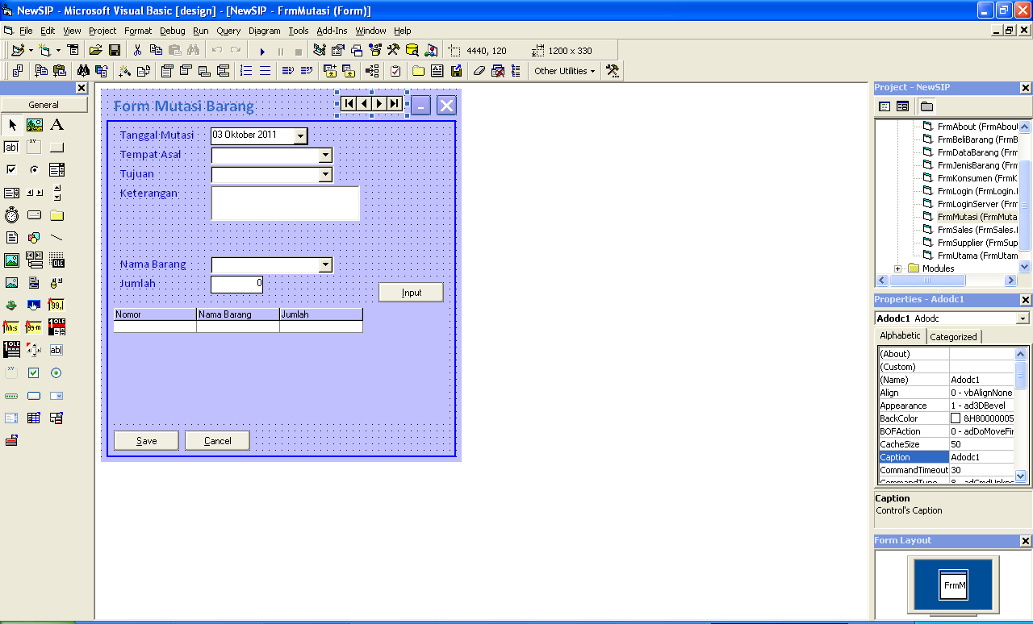

Tampilan form mutasi barang saat dijalankan :

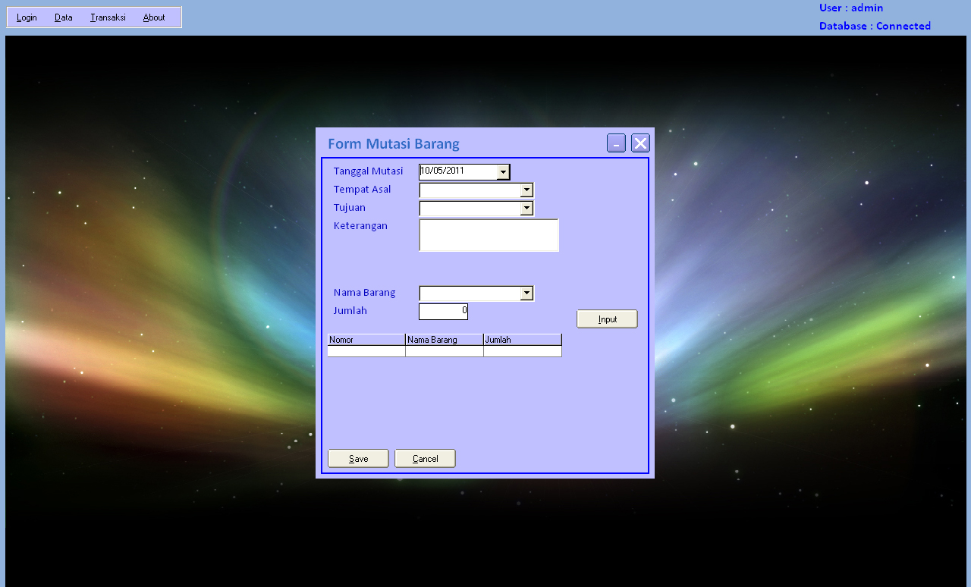

Source Code program :

Dim Keterangan1 As Integer

Private Sub CmbAsal_KeyDown(KeyCode As Integer, Shift As Integer)

Enter KeyCode

End Sub

Private Sub CmbBarang_DropDown()

Adodc1.RecordSource = ""

SQL = "Select KodeBarang,NamaBarang,Satuan from Barang order by kodeBarang"

Set RSFind = DbCon.Execute(SQL)

If RSFind.BOF Then Exit Sub

Adodc1.RecordSource = SQL

Adodc1.Refresh

With CmbBarang

.DataSourceList = Adodc1

.DataFieldList = "NamaBarang"

.Columns(0).Visible = False

.Columns(1).Width = 2000

End With

End Sub

Private Sub cmbBarang_GotFocus()

If IsNull(TxtTgl) Or TxtTgl < Date Then

MsgBox "Tanggal Tidak Valid"

TxtTgl.SetFocus

Exit Sub

ElseIf CmbAsal = CmbTujuan Then

MsgBox "Tempat Asal Jangan Sama Dengan Tempat Tujuan"

CmbTujuan = ""

CmbTujuan.SetFocus

Exit Sub

ElseIf Trim(CmbAsal) = "" Or Not CmbAsal.IsItemInList Then

MsgBox "Tempat Asal masih Kosong"

CmbAsal.SetFocus

Exit Sub

ElseIf Trim(CmbTujuan) = "" Or Not CmbTujuan.IsItemInList Then

MsgBox "Tempat Tujuan Masih Kosong"

CmbTujuan.SetFocus

Exit Sub

ElseIf Trim(TxtKet) = "" Then

MsgBox "Keterangan Masih Kosong"

TxtKet.SetFocus

Exit Sub

End If

End Sub

Private Sub CmbTujuan_KeyDown(KeyCode As Integer, Shift As Integer)

Enter KeyCode

End Sub

Private Sub CmdCancel_Click()

Form_Load

End Sub

Private Sub CmdInput_Click()

If Trim(CmbBarang) = "" And Not CmbBarang.IsItemInList Then

MsgBox "Barang Masih Kosong"

CmbBarang.SetFocus

Exit Sub

ElseIf TxtJumlah = 0 Then

MsgBox "Jumlah masih Kosong"

TxtJumlah.SetFocus

Exit Sub

End If

RsTmp.Find "namaBarang='" & Trim(CmbBarang) & "'", , adSearchForward, 1

If RsTmp.EOF Then

With RsTmp

.AddNew

!noket = RsTmp.RecordCount

!namaBarang = Trim(CmbBarang)

!KodeBarang = Trim(CmbBarang.Columns(0).Text)

!jumlah = Val(TxtJumlah)

.Update

End With

Grid.DataSource = RsTmp

Grid.Refresh

Else

MsgBox "Barang Sudah Diinputkan."

Exit Sub

End If

CmbBarang = ""

TxtJumlah = 0

CmbBarang.SetFocus

End Sub

Private Sub CmdSave_Click()

SQL = "insert into Mutasi values('" & FormatTgl(TxtTgl) & "','" & Trim(CmbAsal) & "','" & Trim(CmbTujuan) & _

"','" & Trim(TxtKet) & "')"

DbCon.Execute SQL

RsTmp.MoveFirst

While Not RsTmp.EOF

With RsTmp

SQL = "insert into DtlMutasi values('" & FormatTgl(TxtTgl) & "','" & !noket & "','" & _

!KodeBarang & "'," & !jumlah & ")"

DbCon.Execute SQL

.MoveNext

End With

Wend

MsgBox "Data Saved"

Bersih

End Sub

Private Sub Form_Load()

Bersih

Adodc1.ConnectionString = ConDB

With RsTmp

.Fields.Append "noKet", adInteger, 4

.Fields.Append "KodeBarang", adVarChar, 50

.Fields.Append "NamaBarang", adVarChar, 50

.Fields.Append "Jumlah", adInteger, 4

.Open

End With

End Sub

Sub Bersih()

TxtTgl = Date

CmbAsal = ""

CmbTujuan = ""

CmbBarang = ""

TxtJumlah = 0

End Sub

Private Sub SSOleDBCombo1_GotFocus()

SendKeys "{F4}"

End Sub

Private Sub Grid_Click()

Keterangan1 = Grid.Columns(0).Text

End Sub

Private Sub Grid_KeyDown(KeyCode As Integer, Shift As Integer)

If KeyCode = 46 Then

If Keterangan1 = 0 Then

MsgBox "Klik Salah Satu Item Di Tabel"

Exit Sub

End If

RsTmp.Find "noket='" & Keterangan1 & "'", , adSearchForward, 1

If Not RsTmp.EOF Then

MsgBox RsTmp!noket & " Dibatalkan"

RsTmp.Delete

End If

Keterangan1 = Keterangan1 + 1

RsTmp.Find "noket='" & Keterangan1 & "'", , adSearchForward, 1

While Not RsTmp.EOF

With RsTmp

.Clone

!noket = !noket - 1

.Update

End With

RsTmp.MoveNext

Wend

Grid.Refresh

End If

End Sub

Private Sub Grid_RowColChange(LastRow As Variant, ByVal LastCol As Integer)

Keterangan1 = Val(Me.Grid.Columns(0).Text)

End Sub

Private Sub TxtJumlah_GotFocus()

cmbBarang_GotFocus

End Sub

Private Sub TxtJumlah_KeyDown(KeyCode As Integer, Shift As Integer)

Enter KeyCode

End Sub

Private Sub TxtKet_KeyDown(KeyCode As Integer, Shift As Integer)

Enter KeyCode

End Sub

Private Sub vbButton1_Click()

Me.WindowState = vbMinimized

End Sub

Private Sub vbButton2_Click()

Unload Me

End Sub